Project Narrative

The Lake Ouachita Vista Trail Endurance Race (LOVIT) is a new ultra-running trail race in Arkansas. The race has been held consecutively for the last three years (2015 to 2017) and is currently awaiting it’s fourth annual race this February. The LOVIT is a 100-mile trail run that is open to both men and women of all ages from all over the country. While the race committee does a good job of recording each year’s data results on the race website, I believe that a database would help the committee record and use the data in meaningful ways that could help grow the race and organization.

Data Questions

I would like to build a database of the runners and results of this race using the data from the last three completed race years. I believe doing so will help the race directors find a target audience of runner’s which would then help grow the race into a larger, more profitable venture. With the given data I will attempt to understand:

* What is the average age of competing runners?
* Who are the fastest runners/what is the race record in terms of finish time?
* Does a gender gap exist between runners?
* What is the percentage of runners traveling from states other than Arkansas, and should the committee advertise in those other states?

Data/Race Parameters

In order to build the database, a few points must first be made. Runners’ are listed in the results section with their first and last name, city, state, age, gender, and time of completion.

Runner’s may or may not compete in the race each consecutive year; however, the race must obviously have runners for there to be a competition. It is worth noting that not all competitors complete the race, which results in a 0 value for ‘finish time as well as ‘race place’. It should be noted that a single race generally takes longer than 24 hours to complete, which can lead to difficulty in datetime storage within SQL.

The race name and distance do not change in this database (LOVIT, 100 miles), but I have worked to position this database in a manner that would allow the committee to change either value and/or add another race to the database if they wish to do so.

**The Conceptual Model**

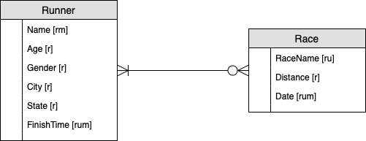

Improved Logical Model

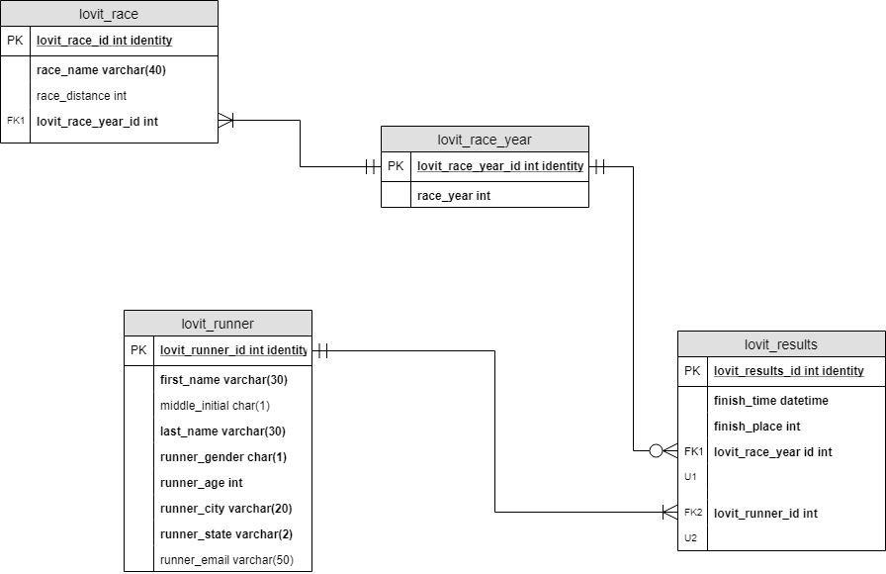

PART 2: Implementation

Insert statements can be seen below within this code. This code should copy/paste into SQL and run appropriately

SQL CODE

--Creating the Runner table

CREATE TABLE Lovit_Runner (

--Columns for the Runner table

Lovit_Runner_ID int identity,

First_name varchar(30) not null,

Middle_Initial char(1),

Last_name varchar(30) not null,

Runner_gender char(1) not null,

Runner_age int not null,

Runner_city varchar(20) not null,

Runner_state varchar(2) not null,

Runner_email varchar(50),

--Constraints on the Runnertable

CONSTRAINT PK_lovit_runner PRIMARY KEY (Lovit_runner_id)

)

--End Creating Runner table

--Altering Runner table to allow for AGE null

ALTER TAble Lovit_Runner

ALTER COLUMN Runner_Age int NULL

--Creating the Race_Year table

CREATE TABLE Lovit_Race_Year (

--Columns for the Race_year table

Lovit_Race_Year_ID int identity not null,

Race_year int not null,

--Constraints on the Race_year table

CONSTRAINT PK_Lovit_Race_Year PRIMARY KEY (Lovit_Race_Year_ID)

)

--End Creating Race_Year table

--Creating the Race table

CREATE TABLE Lovit_Race (

--Columns for the Race table

Lovit_Race_ID int identity not null,

Race_Name varchar(40)not null,

Race_Distance int,

Lovit_Race_YearID int not null

--Constraints on the Race table

CONSTRAINT PK_Lovit_Race PRIMARY KEY (Lovit_Race_ID),

CONSTRAINT FK1_Lovit_Race FOREIGN KEY (Lovit_Race_yearID) REFERENCES Lovit_Race_Year(Lovit_Race_year_ID)

)

--End Creating the Race Table

--Creating the Results table

CREATE TABLE Lovit_Results (

--Columns for the Results table

Lovit_Results_ID int identity not null,

Finish_Time datetime,

Finish_Place int,

Lovit_Race_Year_ID int not null,

Lovit_Runner_ID int not null,

--Constraints on the Results table

CONSTRAINT PK_Results PRIMARY KEY (Lovit_Results_ID),

CONSTRAINT FK1_Results FOREIGN KEY (Lovit_Race_year_ID) REFERENCES Lovit_Race_Year(Lovit_Race_year_ID),

CONSTRAINT FK2_Results FOREIGN KEY (Lovit_Runner_ID) REFERENCES Lovit_Runner(Lovit_Runner_ID)

)

--End Creating the Results Table

--Function for proper Finish_Time data storage

/*

Converts a time presented as 'hh:mm:ss' to a datetime for storage

*/

GO

CREATE OR Alter FUNCTION dbo.GetDateFromTime(@input_time varchar(20))

RETURNS datetime as

BEGIN

DECLARE @return_value datetime

DECLARE @start int, @end int

declare @values TABLE(splitdata decimal(18,4))

SELECT @start = 1, @end = CHARINDEX(':', @input_time)

WHILE @start < LEN(@input_time) + 1 BEGIN

IF @end = 0

SET @end = LEN(@input_time) + 1

INSERT INTO @values(splitdata)

VALUES(convert(decimal(18,4), SUBSTRING(@input_time, @start, @end - @start)))

SET @start = @end + 1

SET @end = CHARINDEX(':', @input_time, @start)

END

DECLARE date_parts CURSOR LOCAL FOR SELECT * FROM @values

DECLARE @curr_date_part decimal(18,4)

set @return_value = 0.0

OPEN date_parts

FETCH NEXT FROM date_parts into @curr_date_part

-- Hours

set @return_value = dateadd(hh, convert(int, @curr_date_part), @return_value)

FETCH NEXT FROM date_parts into @curr_date_part

-- Minutes

set @return_value = dateadd(n, convert(int, @curr_date_part), @return_value)

FETCH NEXT FROM date_parts into @curr_date_part

-- Seconds

set @return_value = dateadd(s, convert(int, @curr_date_part), @return_value)

return @return_value

END

GO

CREATE OR ALTER FUNCTION dbo.GetTimeStringFromDate(@input_date datetime)

RETURNS varchar(20) AS

BEGIN

DECLARE @return_value varchar(20)

set @return_value = convert(varchar(10), DATEDIFF(hh, 0.0, @input_date)) + ':' + convert(varchar(10), DATEDIFF(n, 0.0, @input_date) % 60) + ':' + CONVERT(varchar(10), DATEDIFF(s, 0.0, @input_date) % 60)

RETURN @return_value

END

GO

DECLARE @input_time varchar(20)

SET @input_time = '25:11:00'

DECLARE @sample_date datetime

SELECT @sample_date = dbo.GetDateFromTime(@input_time)

DECLARE @back_to_time varchar(20)

SELECT @back_to_time = dbo.GetTimeStringFromDate(@sample_date)

select

@input_time

, @sample_date

, @back_to_time

--End of Function Creation for proper Finish_Time data storage

--Beginning of all Race Data input

--Adding data to the lovit_race_year table

INSERT INTO Lovit_Race_Year(race_year)

Values

(2015),(2016),(2017)

SELECT * FROM Lovit_Race_Year

--Adding data to the lovit_race table

INSERT INTO Lovit_Race(race_name, Race_Distance, Lovit_Race_YearID)

VALUES

('2015 Lake Ouachita Vista Trail Race', 100,1),

('2016 Lake Ouachita Vista Trail Race', 100,2),

('2017 Lake Ouachita Vista Trail Race', 100,3)

SELECT * From Lovit_Race

--Adding data to the Lovit_Runner table from 2015 Race

INSERT INTO Lovit_Runner(First_name, Last_Name, Runner_gender, Runner_city, Runner_state)

VALUES

('Max', 'Frumes', 'M', 'Brooklyn', 'NY'),

('Justin', 'Walker', 'M', 'Tulsa', 'OK'),

('Paul', 'Schoenlaub', 'M', 'Saint Joesph', 'MO'),

('Noah', 'Churchill', 'M', 'Manila', 'AR'),

('Jason', 'Armitage', 'M', 'Hot Springs', 'AR'),

('Jeremy', 'Day', 'M', 'Magnolia', 'AR'),

('Elizabeth', 'Kimble', 'F', 'Ft.Smith', 'AR'),

('Randy', 'Windle', 'M', 'Hot Springs', 'AR'),

('Ian', 'Zurn', 'M', 'Crystal Lake', 'IL'),

('Rene', 'Villalobos', 'M', 'Fort Worth', 'TX'),

('Laura', 'Range', 'F', 'St.Louis', 'MO'),

('Jim', 'Sweatt', 'M', 'Little Rock', 'AR'),

('Tyler', 'Wilkerson', 'M', 'Russellville', 'AR')

--End of data to Lovit_Runner table 2015 Race

--Adding data to the Lovit_Runner table from 2016 Race

INSERT INTO Lovit_Runner(First_name, Last_Name, Runner_city, Runner_state, Runner_age, Runner_gender)

VALUES

('Hunter', 'Dodds', 'Bilgola Plateau', 'AU', 38, 'M'),

('Dale', 'Humphrey', 'Ely', 'MN', 56, 'M'),

('Paul', 'Schoenlaub', 'St.Joseph', 'MO', 56, 'M'),

('Scott', 'Newcomer', 'York', 'PA', 45, 'M'),

('Tyler', 'Wilkerson', 'Russellville', 'AR', 27, 'M'),

('Jason', 'Willits', 'Bettendorf','IA', 32, 'M'),

('Susan', 'Donnelly', 'Oak Ridge', 'TN', 53, 'F'),

('Adam', 'Stoddard', 'Springfield', 'MO', 42, 'M'),

('Randy', 'Windle', 'Hot Springs', 'AR', 37, 'M'),

('Bill', 'James', 'Hot Springs', 'AR', 46, 'M'),

('Jason', 'Armitage', 'Hot Springs', 'AR', 43, 'M'),

('Gerardo', 'Ramirez', 'Fort Worth', 'TX', 43, 'M'),

('Kurt', 'Hauser', 'Hot Springs', 'AR', 51, 'M'),

('Paul', 'Turner', 'Conway', 'AR', 52, 'M'),

('Joshua', 'Sun', 'Davenport', 'IA', 30, 'M'),

('Brandon', 'Allen', 'Little Rock', 'AR', 33, 'M'),

('Rusty', 'Harvey', 'Gassville', 'AR', 30, 'M'),

('Aubrey', 'Callahan', 'Grand Prairie', 'TX', 33, 'F'),

('Tim', 'Boggs', 'Zanesville', 'OH', 54, 'M'),

('Ben', 'Mansur', 'Little Rock', 'AR', 44, 'M'),

('Shannon', 'McDowell', 'Paragould', 'AR', 39, 'F'),

('Rene', 'Villalobos', 'Fort Worth', 'TX', 57, 'F'),

('Ian', 'Zurn', 'Crystal Lake', 'IL', 34, 'M')

--End of data for Lovit_Runner 2016 Race

--Adding data to the Lovit_Runner table from 2017 Race

INSERT INTO Lovit_Runner(First_name, Last_Name, Runner_city, Runner_state, Runner_age, Runner_gender)

VALUES

('Tyler', 'Wilkerson', 'Russellville', 'AR', 28, 'M'),

('Paul', 'Schoenlaub', 'St. Joseph', 'MO', 57, 'M'),

('David', 'Batchelder', 'Tulsa', 'OK', 24, 'M'),

('Bailee', 'Wilkerson', 'Russellville', 'AR', 26, 'F'),

('Gerardo', 'Ramirez', 'Fort Worth', 'TX', 44, 'M'),

('Randy', 'Windle', 'Hot Springs', 'AR', 38, 'M'),

('Kamm', 'Prongay', 'Portland', 'OR', 53, 'F'),

('Zac', 'Lundgren', 'Minneapolis', 'MN', 26, 'M'),

('Shalini', 'Kovach', 'Ballwin', 'MO', 41, 'F'),

('Aaron', 'Lebell', 'Jefferson', 'TX', 45, 'M'),

('Robert', 'Misener', 'Hot Springs', 'AR', 46, 'M'),

('Tabatha', 'Park', 'Royal', 'AR', 48,'F'),

('Jason', 'Armitage', 'Hot Springs', 'AR', 44, 'M'),

('Shannon', 'Hampton', 'Bentonville', 'AR', 44, 'M'),

('Terry', 'Jamieson', 'Ozark', 'MO', 53, 'M'),

('Jeremy', 'Brownfield', 'Ozark', 'MO', 36, 'M'),

('James', 'Fountain', 'Jessieville', 'AR', 43, 'M'),

('Darin', 'Anderson', 'Pearcy', 'AR', 45, 'M'),

('Kimmy', 'Riley', 'Mabelvale', 'AR', 55, 'F'),

('Nancy', 'Marks', 'Round Rock', 'TX', 56, 'F'),

('Aubrey', 'Callihan', 'Grand Prairie', 'TX', 34, 'M'),

('Jim', 'Sweatt', 'Little Rock', 'AR', 61, 'M'),

('Johnny', 'Eagles', 'Little Rock', 'AR', 65, 'M'),

('Jim', 'Hubbard', 'Ozark', 'MO', 50, 'M'),

('Rob', 'Henley', 'Fayetteville', 'AR', 34, 'M')

--End of Lovit_Runner data for 2017 Race

SELECT * FROM Lovit_Runner

--Adding data (trial run) to the Lovit_Results table 2015 Race

INSERT INTO Lovit_Results(Lovit_Runner_ID,Finish_Time, Finish_Place,Lovit_Race_Year_ID)

VALUES

(1, dbo.GetDateFromTime('23:19:42'), 1, 1)

SELECT * FROM Lovit_Results

--Adding more data to the Lovit_Results table 2015 Race

INSERT INTO Lovit_Results(Lovit_Runner_ID, Finish_Time, Finish_Place, Lovit_Race_Year_ID)

VALUES

(2, dbo.GetDateFromTime('25:11:00'), 2, 1),

(3, dbo.GetDateFromTime('26:22:02'), 3, 1),

(4, dbo.GetDateFromTime('27:55:47'), 4, 1),

(5, dbo.GetDateFromTime('31:02:55'), 5, 1),

(6, dbo.GetDateFromTime('32:59:30'), 6, 1),

(7, dbo.GetDateFromTime('34:21:00'), 7, 1),

(8, null, null, 1),

(9, null, null, 1),

(10, null, null, 1),

(11, null, null, 1),

(12, null, null, 1),

(13, null, null, 1)

--End adding data to the Lovit_Results 2015 Race

--Adding data to the Lovit Results from the 2016 race

INSERT INTO Lovit_Results(Lovit_Runner_ID, Finish_Time, Finish_Place, Lovit_Race_Year_ID)

VALUES

(14, dbo.GetDateFromTime('21:52:34'), 1, 2),

(15, dbo.GetDateFromTime('23:37:55'), 2, 2),

(16, dbo.GetDateFromTime('23:44:24'), 3, 2),

(17, dbo.GetDateFromTime('24:31:17'), 4, 2),

(18, dbo.GetDateFromTime('25:26:52'), 5, 2),

(19, dbo.GetDateFromTime('26:44:42'), 6, 2),

(20, dbo.GetDateFromTime('27:28:20'), 7, 2),

(21, dbo.GetDateFromTime('28:14:58'), 8, 2),

(22, dbo.GetDateFromTime('29:07:58'), 9, 2),

(23, dbo.GetDateFromTime('29:28:24'), 10, 2),

(24, dbo.GetDateFromTime('29:28:24'), 11, 2),

(25, dbo.GetDateFromTime('29:41:42'), 12, 2),

(26, dbo.GetDateFromTime('29:45:31'), 13, 2),

(27, dbo.GetDateFromTime('30:34:58'), 14, 2),

(28, dbo.GetDateFromTime('32:12:58'), 15, 2),

(29, dbo.GetDateFromTime('33:08:58'), 16, 2),

(30, dbo.GetDateFromTime('33:08:58'), 17, 2),

(31, dbo.GetDateFromTime('33:45:58'), 18, 2),

(32, null, null,2),

(33, null, null,2),

(34, null, null, 2),

(35, null, null, 2),

(36, null, null, 2)

--Adding data to Lovit_results table for 2017 results

INSERT INTO Lovit_Results(Lovit_Runner_ID, Finish_Time, Finish_Place, Lovit_Race_Year_ID)

VALUES

(37, dbo.GetDateFromTime('22:20:00'), 1, 3),

(38, dbo.GetDateFromTime('22:41:00'), 2, 3),

(39, dbo.GetDateFromTime('23:11:00'), 3, 3),

(40, dbo.GetDateFromTime('23:34:00'), 4, 3),

(41, dbo.GetDateFromTime('25:05:00'), 5, 3),

(42, dbo.GetDateFromTime('26:16:00'), 6, 3),

(43, dbo.GetDateFromTime('27:09:00'), 7, 3),

(44, dbo.GetDateFromTime('27:47:00'), 8, 3),

(45, dbo.GetDateFromTime('27:54:00'), 9, 3),

(46, dbo.GetDateFromTime('28:13:00'), 10, 3),

(47, dbo.GetDateFromTime('28:43:00'), 11, 3),

(48, dbo.GetDateFromTime('30:29:00'), 12, 3),

(49, dbo.GetDateFromTime('39:29:00'), 13, 3),

(50, dbo.GetDateFromTime('30:50:00'), 14, 3),

(51, dbo.GetDateFromTime('31:29:00'), 15, 3),

(52, dbo.GetDateFromTime('31:29:00'), 16, 3),

(53, dbo.GetDateFromTime('31:31:00'), 17, 3),

(54, dbo.GetDateFromTime('31:31:00'), 18, 3),

(55, dbo.GetDateFromTime('31:41:00'), 19, 3),

(56, dbo.GetDateFromTime('33:40:00'), 20, 3),

(57, dbo.GetDateFromTime('33:40:00'), 21, 3),

(58, null, null, 3),

(59, null, null, 3),

(60, null, null, 3),

(61, null, null, 3)

--End of data for Lovit_Results table regarding year 2017

Select * From Lovit_Runner

SELECT * FROM Lovit_Results

--Viewing Top Runner's of All Time on LoVit Race

SELECT

Lovit_Runner.First_name,

Lovit_Runner.Last_name,

dbo.GetTimeStringFromDate(Lovit_Results.Finish_Time) as 'Finish Time',

Lovit_Race_Year.Race_Year

FROM Lovit_Results

JOIN Lovit_Runner on lovit_runner.Lovit_Runner_ID = Lovit_results.Lovit_Runner_ID

JOIN Lovit_Race_Year on lovit_race_year.lovit_race_year_id = lovit_results.lovit_race_year_id

WHERE Finish_Time is not null

ORDER BY Finish_Time ASC

SELECT * FROM Lovit_Runner

--Finding the total number of Arkansas Runner's

SELECT COUNT (Runner_State) as 'Out-of-State Runners'

FROM Lovit_Runner

WHERE Runner_state <> 'AR'

SELECT COUNT (Runner_State) as 'AR Runners'

FROM LOVIT_RUNNER

WHERE Runner_State = 'AR'

--Finding the average age of competing runner

SELECT AVG (Runner_Age) as 'Average Age'

FROM Lovit_Runner

--Finding total number female runners

SELECT COUNT (Runner_Gender) as 'Females'

FROM Lovit_Runner

WHERE Runner_Gender = 'F'

SELECT COUNT (Runner_Gender) as 'Males'

FROM Lovit_Runner

WHERE Runner_Gender = 'M'

Questions answered by SQL

Fastest Lovit Runners

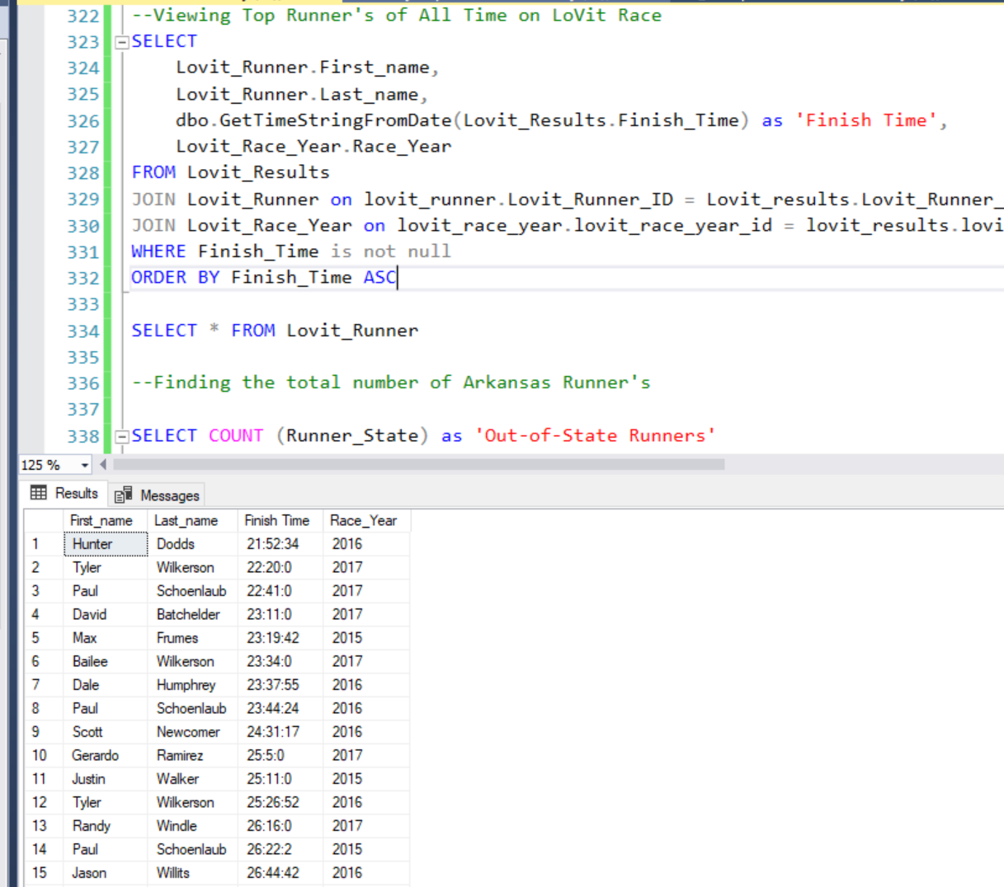

Average Runner Age

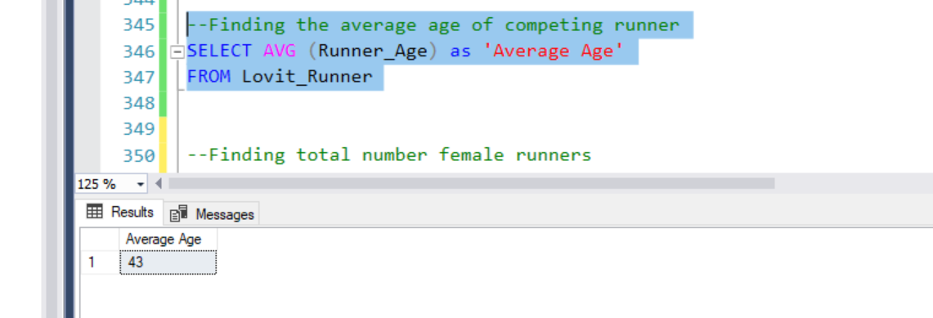

In-State vs Out-Of-State Runners (where should advertisement be placed)

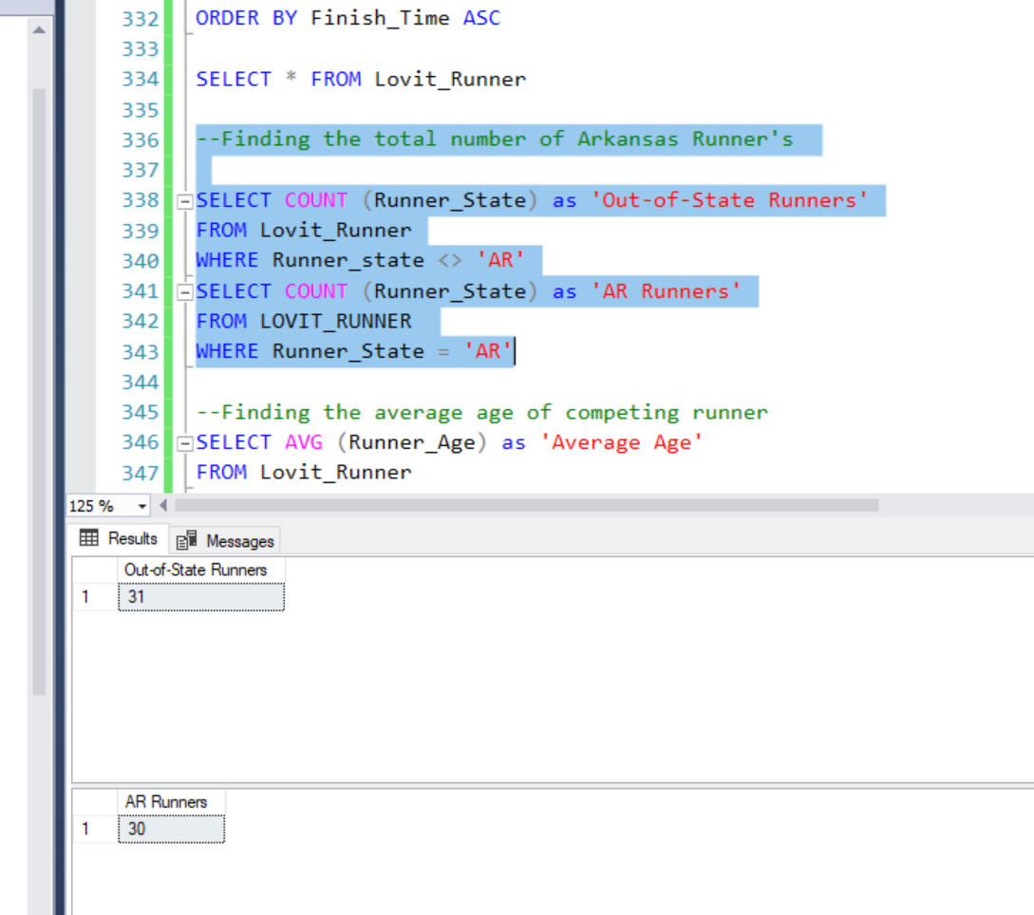

Number of Males vs Females totaled

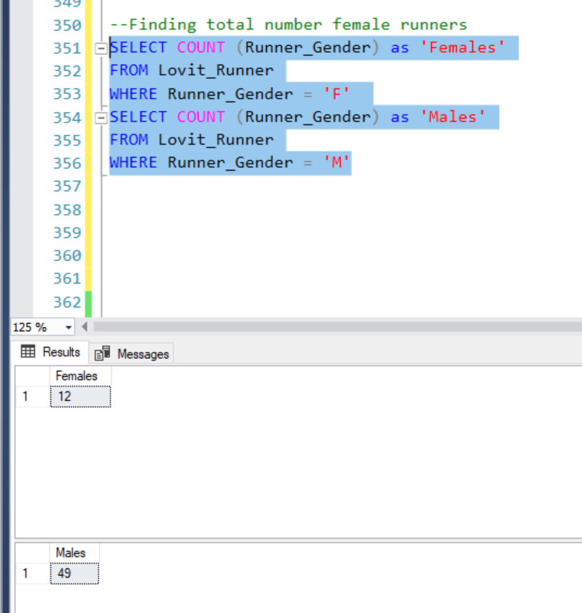

Data implementation into Excel

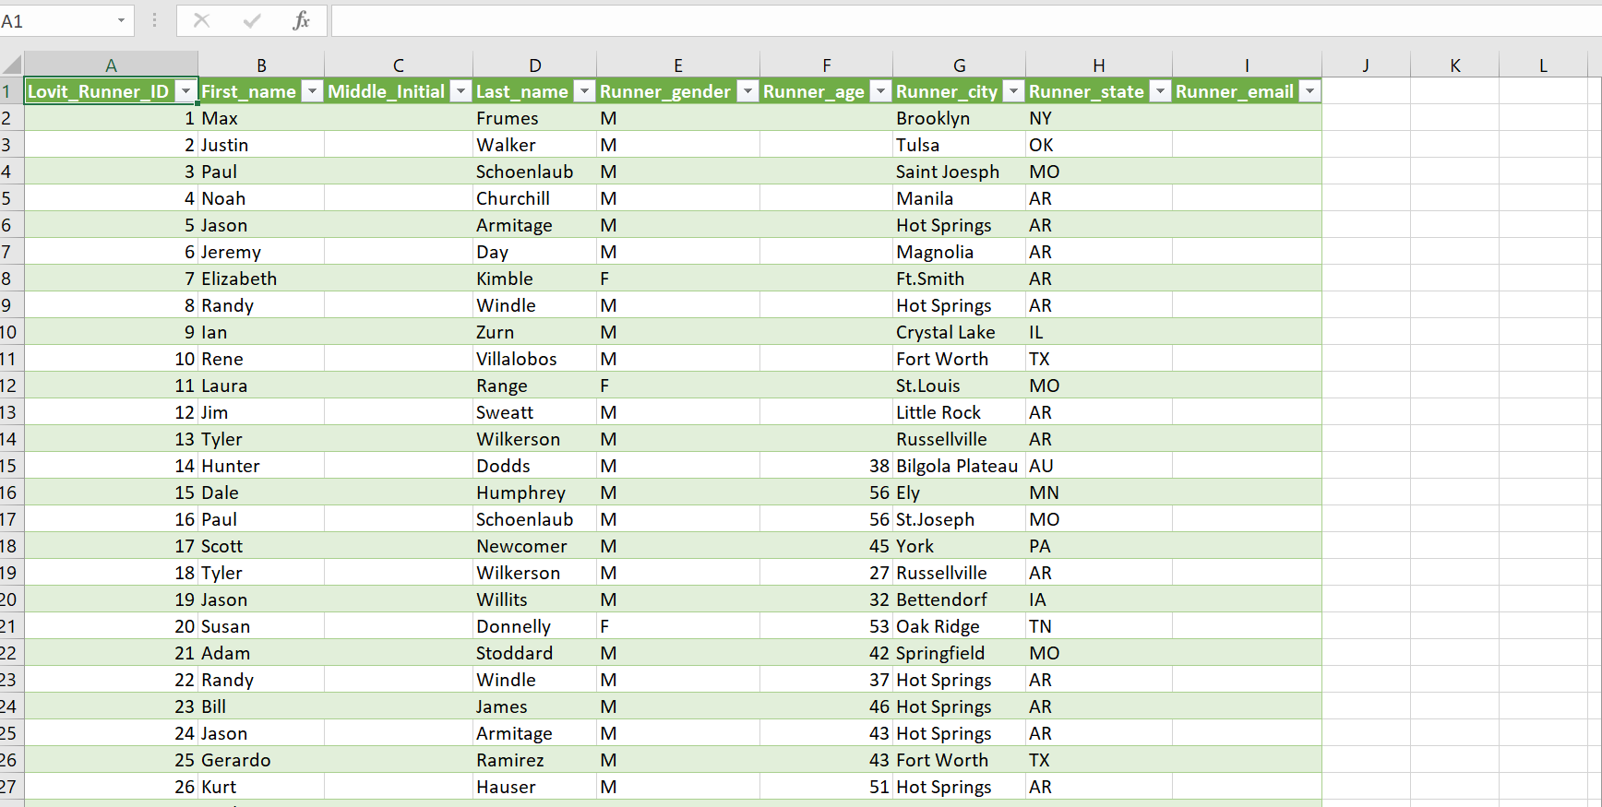

Lovit All Time Runners in Excel

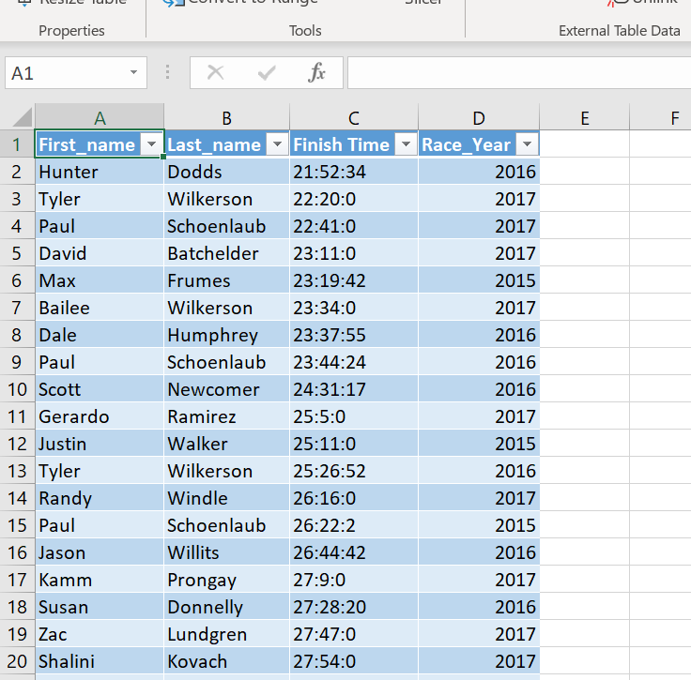

Reflection:

There are a few things that I would like to implement into this database to make it more comprehensive for further use that would require working with the race organizers. It would be beneficial to have the runners provide email addresses to be placed into the database to make it easier for contact and spread of information between runners and race organizers. It would also be a good idea to require runners to make a unique login to help store runners individually within the database. While my database allows for redundancy by listing sometimes listing a runner twice, this may or may not be beneficial for the growth of the Lovit organization. It is difficult to know how the organization would like to optimize this database without personally meeting with the organizers to discuss organizational goals.